Diode Typical Characteristics:

* Forward bias voltage ($V_{F}$) = 0.7V (silicon) 0.3V(germanium)
* Forward current ($I_{F}$) $≈10mA up to Max forward current$
* Diode power ($P_{D}$) = $I_{F} x V_{F}$
* Max forward current $(I_{F\left(Max\right)})= \frac{P_{D(Max)}}{V_{F}}$
* Reverse voltage ($V_{R})≈0-75V$
* Reverse current ($I_{R}$) “The reverse current $I_{R}$ is at first equal to $I_{F}$; then it falls off to the reverse leakage current level,” (Bell p.79)
* Reverse leakage current ($I_{S})≈0.05μA$
* Reverse breakdown voltage ($V_{R(Max)}) ≈75V$
* Reverse recovery time ($t_{rr}) ≈4nS to 50nS$

“The reverse recovery time $t_{rr}$ is the time required for the reverse current to fall to $I_{S}$.” (Bell p.75)

“The speed with which a diode can be switched is determined by the reverse recovery time of the device.”(Bell p.76)

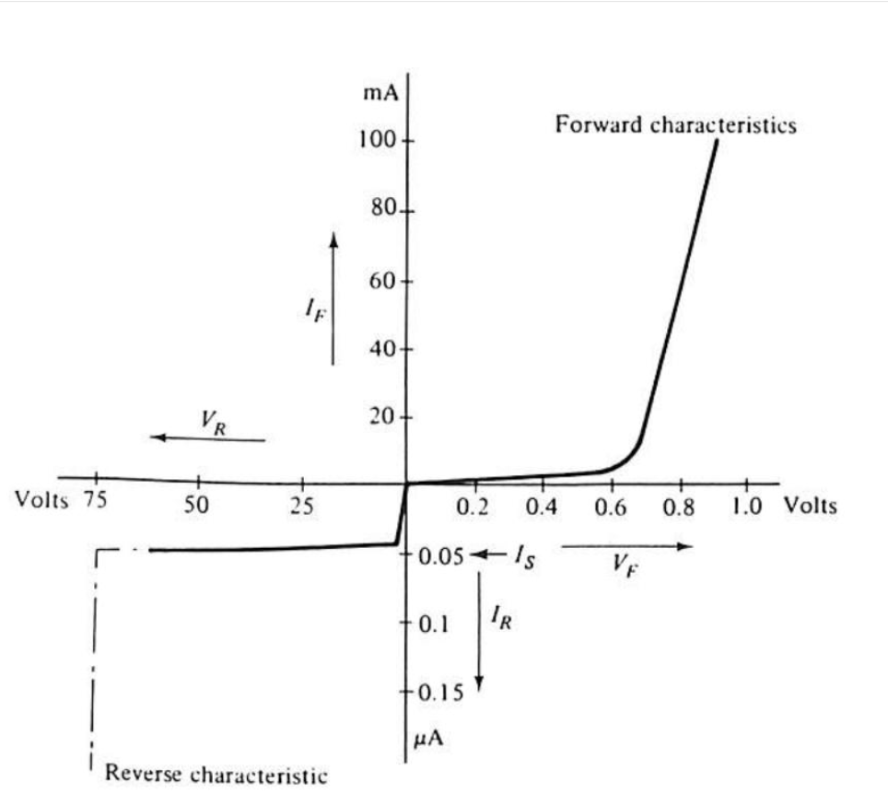

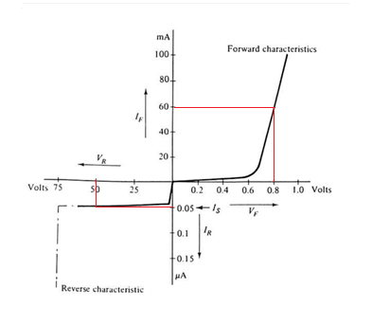Diode **Static** Resistance:

* Notice when the diode is forward biased at $V_{F}=0.8v, I_{F}=60mA$
  + We can now solve for the Diode Static Resistance when $I_{F}=60mA$.
 $R_{D}=\frac{V_{F}}{I_{F}}$

 $R_{D}=\frac{0.8V}{60mA}$

$R_{D}=13.333Ω$

+ How about solving the Diode Static Resistance when the diode is reverse biased at $V_{R}= -50V$
 $R_{D}=\frac{V_{R}}{I_{S}}$

 $R_{D}=\frac{50V}{.05μA}$

$R_{D}=1GΩ$

+ This shows us that the Diode is acting like a switch.

Diode **Dynamic** Resistance:

* Very similar to Transistors, as AC voltages are applied to diodes they exhibit a dynamic resistance that can be calculated using the below formula.

$r^{'}d= \frac{26mV}{I_{F}}$

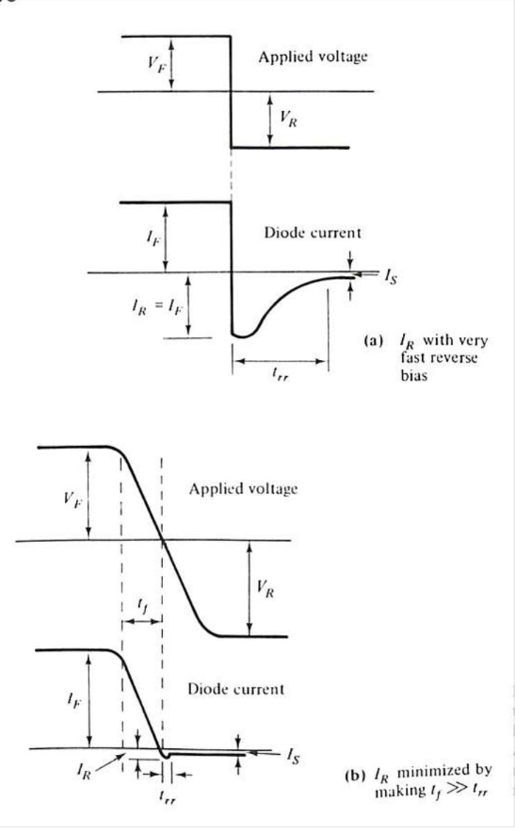

$t_{rr}$ and Frequency Response.

* Practical Design considerations for switching diodes. The impact of the diode’s recovery time can affect the circuits high frequency response. In order to negate the impact of the diodes $t_{rr}$, a diode with a recovery time that is ten times less than the desired Rise Time or Fall Time should be used.

 $t_{rr}≤$ $\frac{{Time}_{Rise/Fall}}{10}$

${Time}_{Rise/Fall}≥(t_{rr}×10$ + )

${FC}_{H}=\frac{.35}{{Time}_{Rise}}$